Virtual and Augmented Reality Usage Analysis - Entertainment Sector

Pooja Joshi & E.Code [E25007]

# Overview

This report presents an analysis of Virtual Reality (VR) and Augmented Reality (AR) usage in the entertainment sector. It focuses on adoption rates, average time spent by users, and popularity trends from 2015 to 2023, based on a synthetic dataset designed to reflect realistic usage trends.

# Objective :

· To assess the growth and impact of VR/AR technologies in the entertainment sector.

· To analyze key trends such as adoption rates, time spent, and user engagement (popularity) for both VR and AR over time.

# Assigned Task(s):

· Analyze the VR/AR adoption trends from 2015 to 2023.

· Visualize average time spent in VR/AR experiences.

· Compare the popularity of VR versus AR in the entertainment sector.

# Task Details :

**Task 1: Analyze Adoption Trends**

* **Status**: Completed
* **Details**: A line plot was created to display the adoption rates of VR and AR technologies from 2015 to 2023. The analysis shows that both technologies have seen growth over the years, with VR generally having a higher adoption rate than AR in most years.

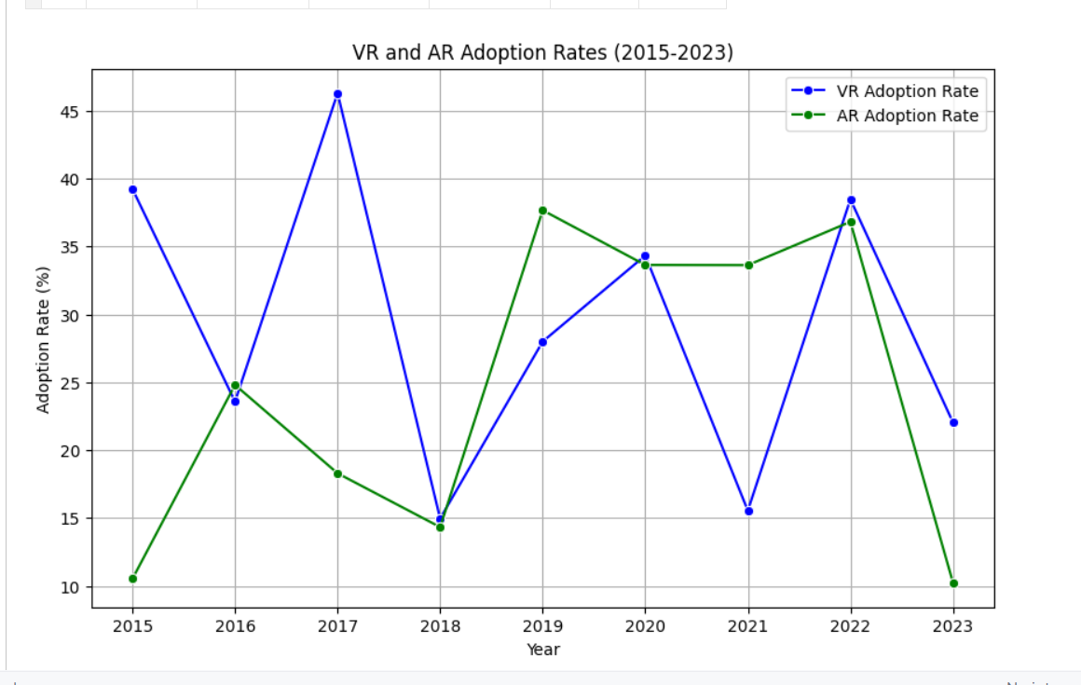

**Task 2: Time Spent in VR/AR**

* **Status**: Completed
* **Details**: A bar plot compares the average time users spend in VR and AR sessions. The analysis indicates that, on average, users spend more time in VR sessions compared to AR.

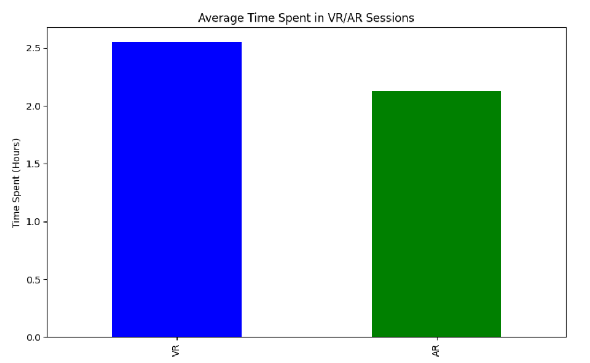

**Task 3: Popularity Comparison**

* **Status**: Completed
* **Details**: A line plot was created to compare the popularity trends of VR versus AR content. The results show that while both VR and AR have fluctuated in popularity over the years, VR tends to have a slight edge in terms of user engagement.

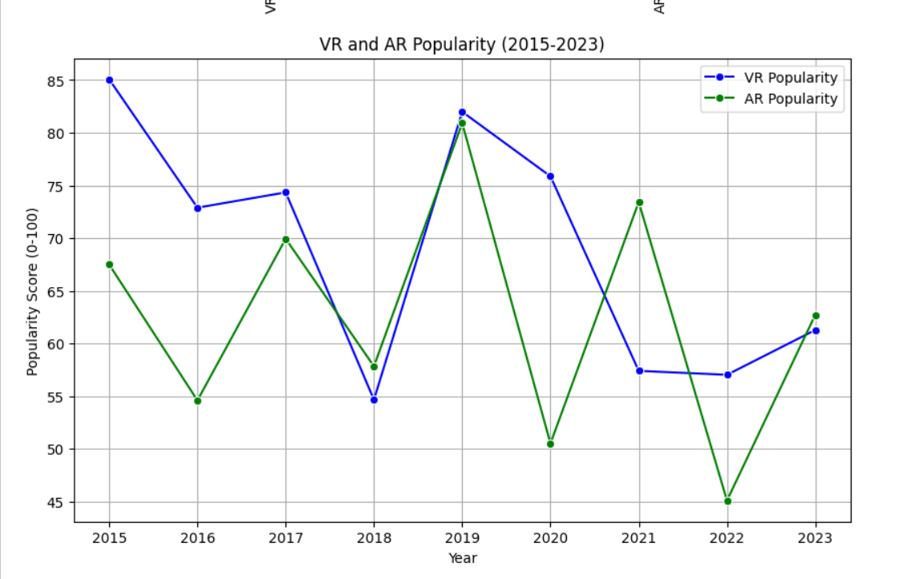

# Progress

· **Accomplishments**: All assigned tasks have been completed, with clear visualizations showing the trends in VR/AR adoption, usage time, and popularity.

· **Metrics**:

* **VR Adoption Rate** (2015-2023): Ranges from 14.6% to 48.6%.
* **AR Adoption Rate** (2015-2023): Ranges from 7.9% to 40.3%.
* **Average Time Spent** in VR sessions: 3.82 hours (2015) to 1.95 hours (2019).
* **Average Time Spent** in AR sessions: 2.14 hours (2015) to 2.70 hours (2019).

# Challenges and Solutions:

· **Challenges Faced**: The absence of real-world VR/AR data posed a limitation.

· **Solutions Implemented**: A synthetic dataset was generated to simulate realistic VR/AR trends for the analysis.

# Next Steps :

· **Upcoming Tasks**: Integrate real-world VR/AR data once available to refine the analysis.

· **Goals**: Conduct further analysis on how specific content genres are impacted by VR/AR adoption.

# Conclusion :

* **Summary**: This report highlights key insights into the adoption, usage, and popularity trends of VR and AR technologies in the entertainment sector. Although the analysis is based on a synthetic dataset, the trends provide a strong foundation for understanding how these technologies are shaping the future of entertainment.
* **Acknowledgments**: Thank the audience for their time and attention.

# Instructions:

1. Use Google Docs. Single Column
2. TNR stands for Times New Roman: B - Bold
3. Use images as required with proper references
4. Use charts, tables as per your requirement.
5. Number of Pages: 2 to 8 for each task report.